Daniel DeCarlo

Box # 107

Cairn University School of Business

CIS122 Essentials of Networking

Project # 1

Project objective:

* The object of this project is to create data cables that can be used to build our network and connect different parts so it is functional.
* To buy equipment that is within budget.
* To create functional data cables while following the 568B standard.

Equipment used:

|  |  |  |  |  |
| --- | --- | --- | --- | --- |
| Equipment Description | Vendor | Vendor Item # | Retail price | Actual price (if known) |
| Zoostliss 11 in 1 Professional Network Computer Maintenance Repair Tools Rj45 Rj11 Cat5 LAN Network Tool Kit | Amazon/ Zoostliss | 5324636 | $21.89 |  |
| SolidLink CAT5e 1000ft Premium UTP Ethernet Cable 24AWG 1000 Feet Bulk LAN Network Wire, White | Amazon/ SolidLink | SL600 | $46.99 |  |
| RJ45 Connectors,SHD Cat6 Connector Cat5e Connectors Cat5 Connectors RJ45 Ends Ethernet Cable Crimp Connectors-100Pcs | Amazon/SHD | RJSHD-100 | $8.99 |  |

Detailed list of software and operating platforms used, including version numbers and licensing requirements:

NO SOFTWARE USED IN THIS PROJECT.

Network diagram:

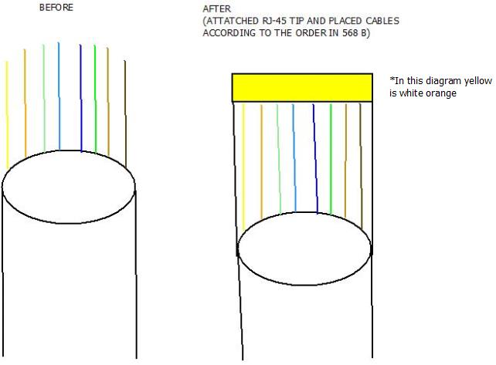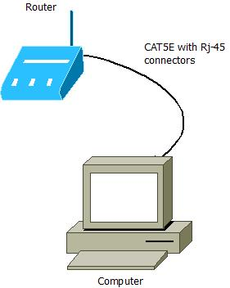

Configurations:

When configuring a network cable use the following steps:

1. Take the right amount of CAT5e cable and cut out enough that it will connect to the desired places. (Make sure there is a tiny bit of slack about one or two inches so the cable won’t be damaged if it is stretched).
2. Remove the outer shell of the wire with the wire strippers in the network kit or a good pair of scissors.
3. Untwist the wires and separate them and make them all level and flat.
4. Arrange the wires according to the specified TIA style. There are two different styles, 568A and 568B. For this project we will be using 568B. The order of the wires is as follows:

* White Orange
* Orange
* White Green
* White Blue
* Blue
* Green
* White brown
* Brown

1. After the cables are in order and pressed flat together take the rj-45 tip.
2. With the rj-45 tip in hand put the wire in with the clip facing down and the flat side facing up.
3. When the wires are in the right place take the crimpers from the network kit and crimp the tip to the wire.
4. After the wire is crimped tug on the tip lightly to make sure it is secure.
5. Perform steps 2-8 for the other end of the wire.
6. Last plug in your new data cable and see if it works.
7. If the cable doesn’t work remove the tip and try again until there is a connection.

For clearer instructions and Visuals visit the site below:

<https://www.wikihow.com/Make-a-Network-Cable>

# Works Cited

Wikihow. *How to Make a Network Cable*. n.d. https://www.wikihow.com/Make-a-Network-Cable. 23 Janurary 2019.